**DAY 3**

**PRACTICE DQL STATEMENT**

**Write SQL statement for the following**

**1. To find all managers with salary >1500**

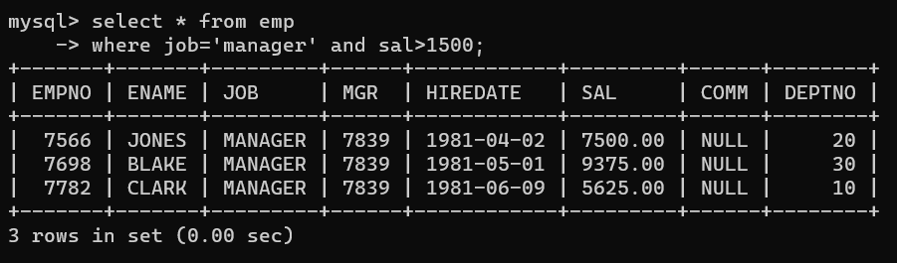

**2. list all employees with sal >1200 and < 2000** 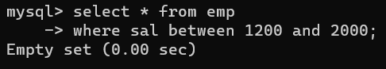

**3. list all employees with sal is 1600 or sal is 800 or sal is 1900**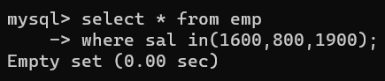

**4. list all employees with R at second last position in name** 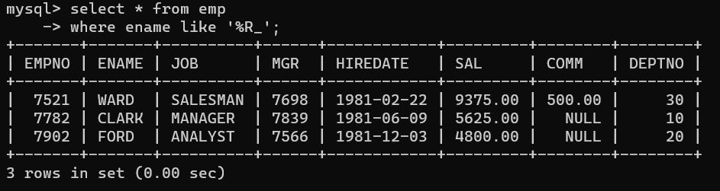

**5. List all employees with name starts with A and ends with N**

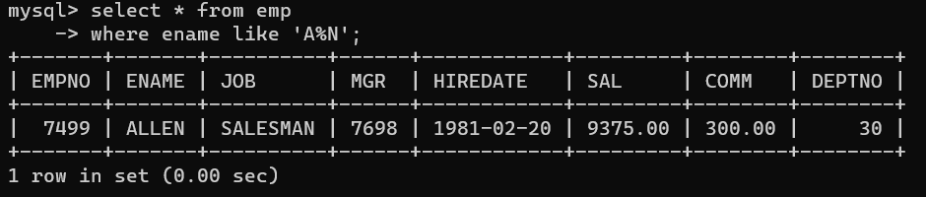

**Q2. Solve following**

**1. list all employees with salary > 1250 and dept no=30**

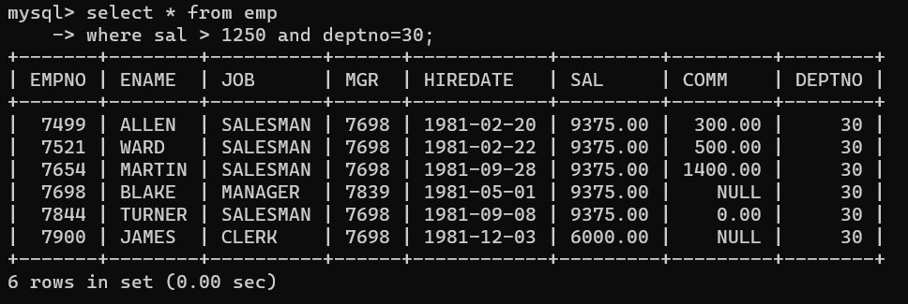

**2. list all employees with salary >=1250 and <= 3000** 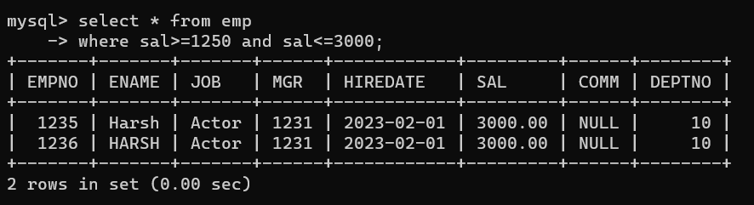

**3. list all employees with salary >1250 and < 3000** 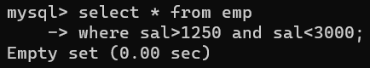

**4. list all employees with salary either equal to 3000 or 1250 or 2500** 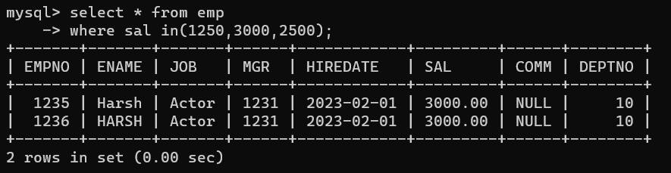

**5. list all employee with name=SMITH** 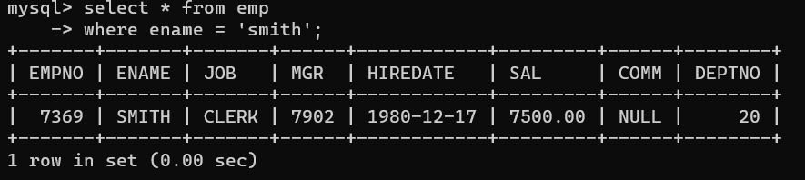

**6. list all employees with name starting with S** 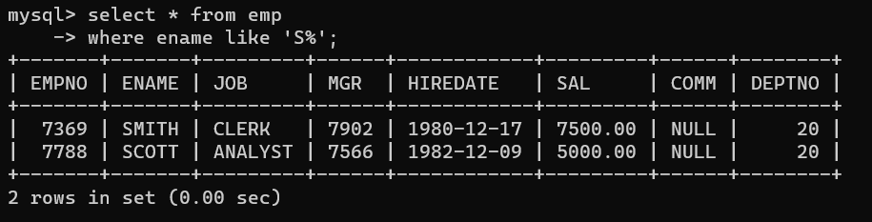

**7. list all employees with name ending with S** 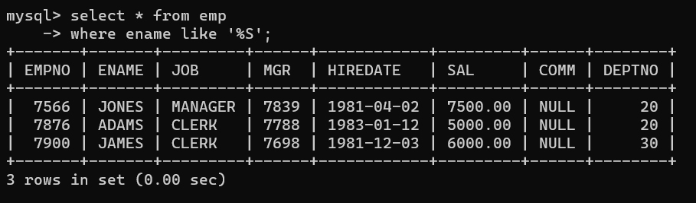

**8. list all employees with name contains I at 2nd position** 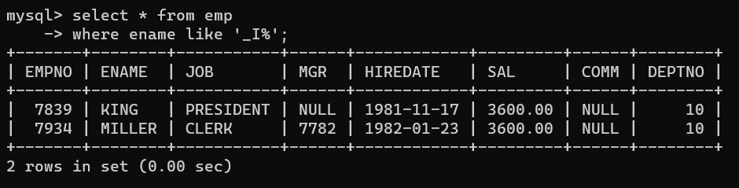

**9. list all employees with name starts with A ends with N and somewhere in between L is there** 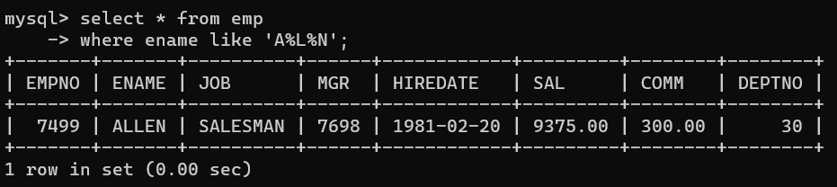

**10. list all employees with name starts with A and B at 3 rd position and P at second last position** 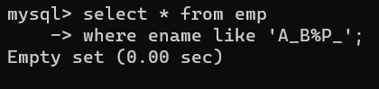

**11. List all employees with name starts with either A or starts with S or starts with W**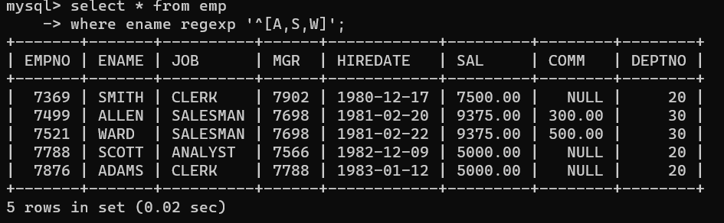

**PRACTICE AGGREGATE FUNCTIONS**

**12. find max sal and min sal for each job**

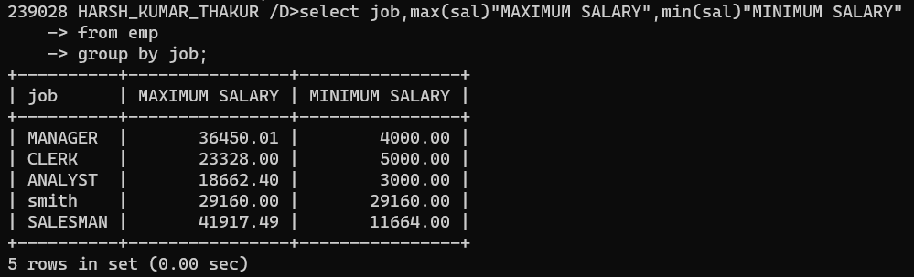

**13. find how many employess have not received commission**

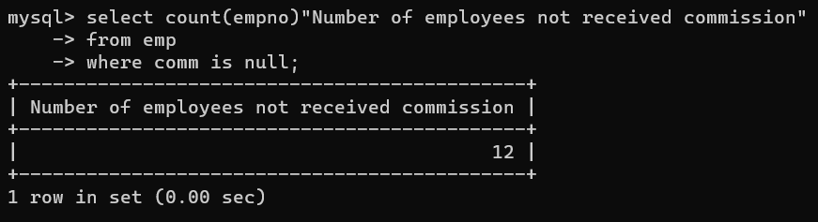

**14. find sum of sal of all employees working in dept no 10** 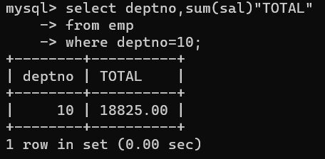

**15. find maximum salary,average sal for each job in every department** 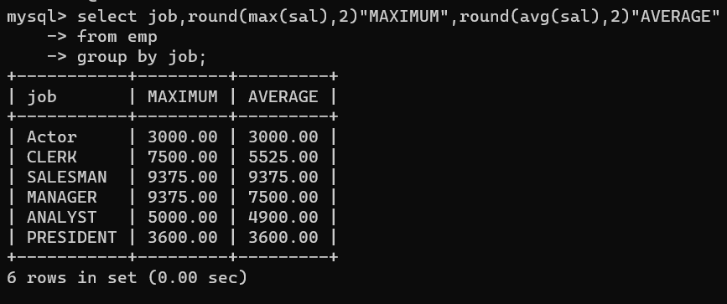

**16. find max salary for every department if deptno is > 15 and arrange data in deptno order.** 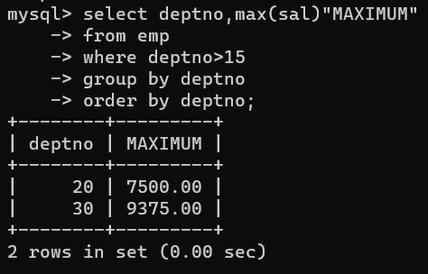

**17. find sum salary for every department if sum is > 3000** 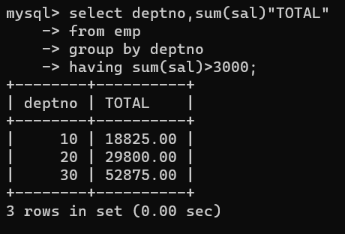

**18. list all department which has minimum 5 employees** 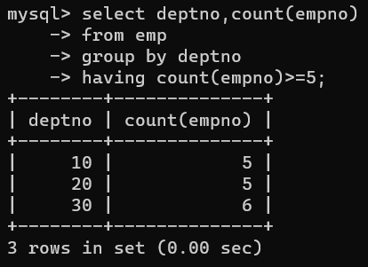

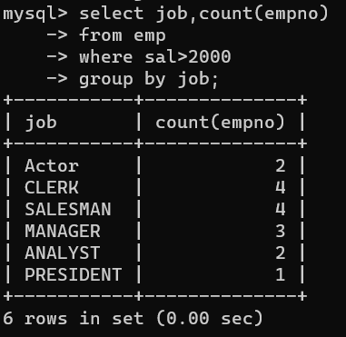**19. count how many employees earn salary more than 2000 in each job**

**20. list all enames and jobs in small case letter**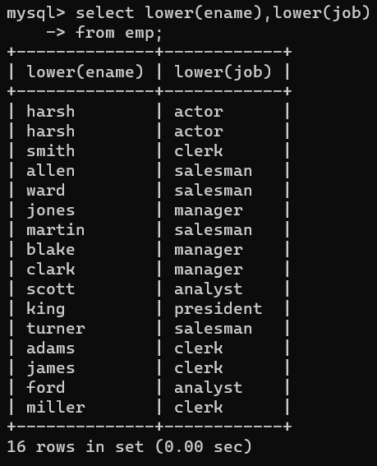

**21. list all names and jobs so that the length of name should be 15 if it is smaller then add spaces to left**

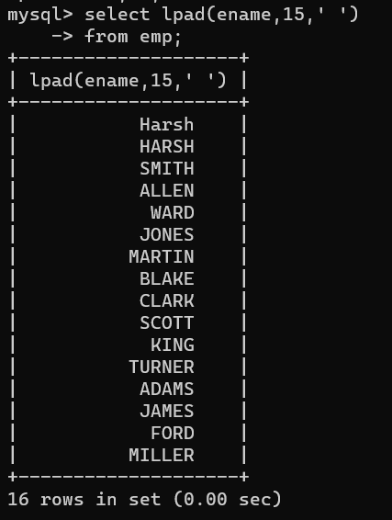

**22. display min sal,max sal, average sal for all employees working under same manager** 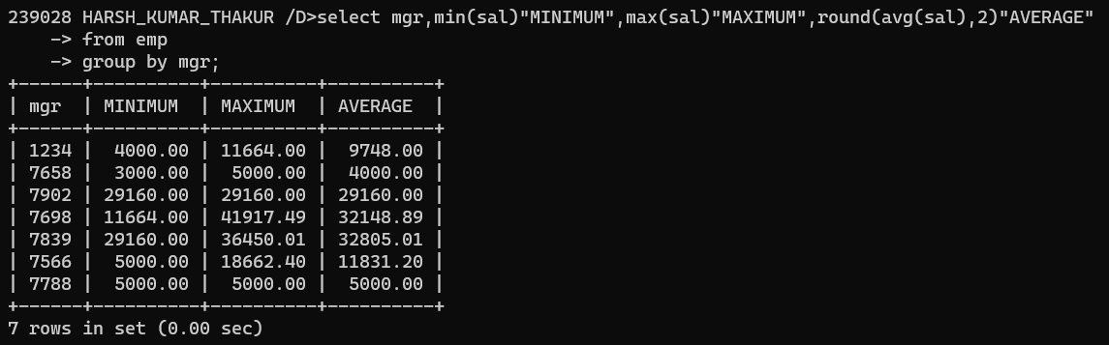

**23. find sum of total earnings(sal+comm), average of sal+comm, for all employees who earn sal > 2000 and work in either dept no 10 or 20** 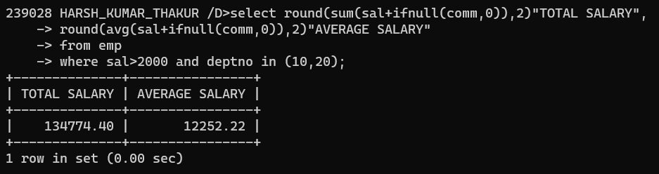

**24. list all employees who joined in Aug 1980 and salary is >1500 and < 2500** 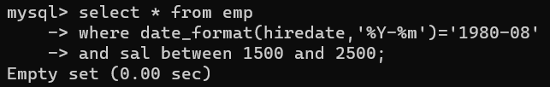

**25. list all employees joined in either aug or may or dec** 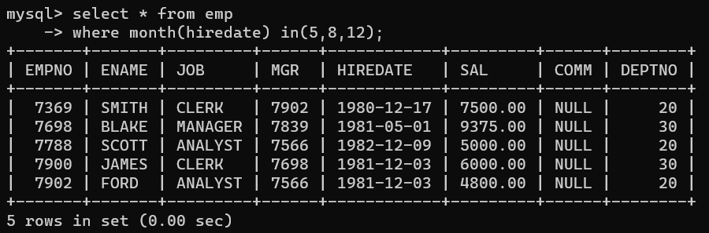

**26. display name and hiredate in dd/mm/yy format for all employees whose job is clerk and they earn some commission** 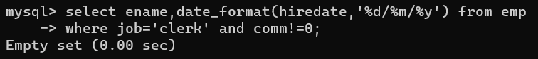

**27. list empcode,empno,name and job for each employee. (note :empcode is 3 to 5 characters from name and last 2 characters of job)** 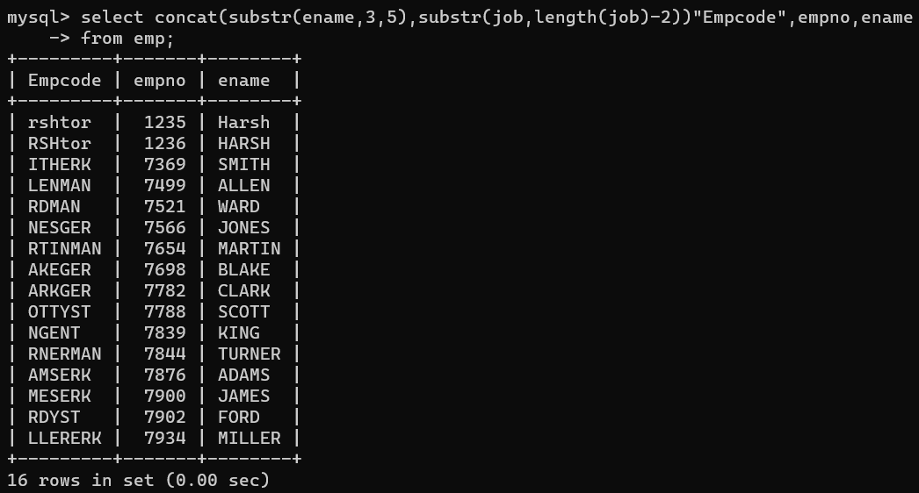

**28. display thousand separator and $ symbol for commission if it is null then display it as 0 for all employees whose name starts with A and ends with N** 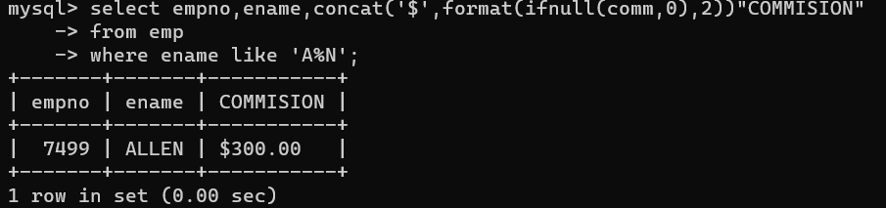

**29. Display empid,name,sal,comm,remark Remark should base on following conditions comm >= 600 "excellent Keep it up" if it < 600 or not null "good" otherwise "Need improvement"** 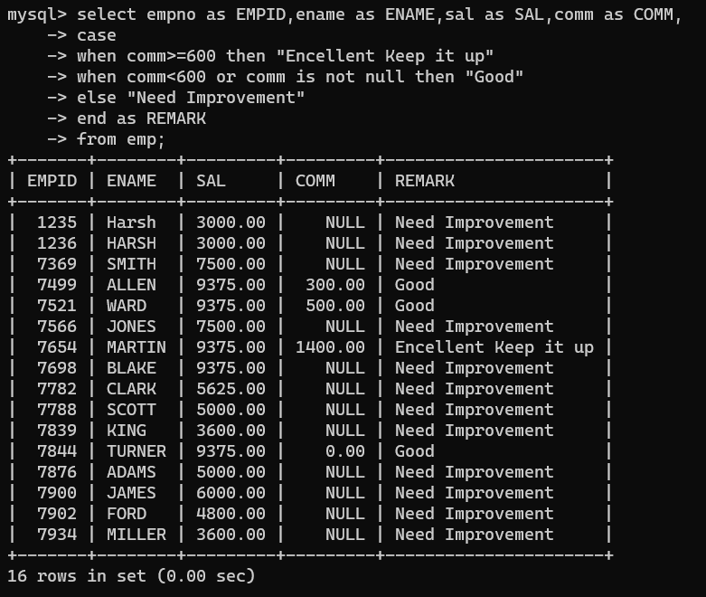

**30. Display empid, name, deptno and department name by using following conditions. dept 10 then "Hr" if 20 then "Admin" if 30 then "accounts" otherwise purchase**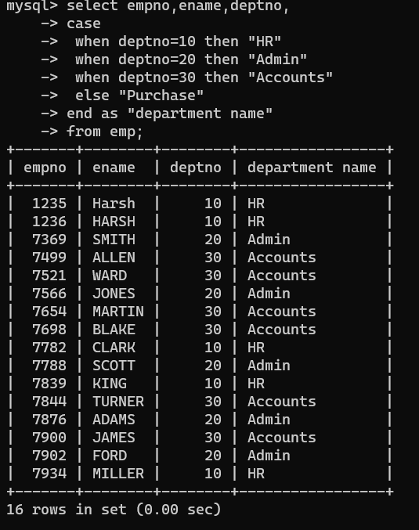

**31. Practice creating following tables MySQL syntax:**

**create table mydept_DBDA ( deptid int primary key, dname varchar(20) not null unique, dloc varchar(20) )**

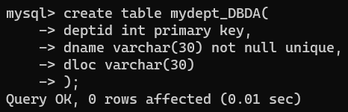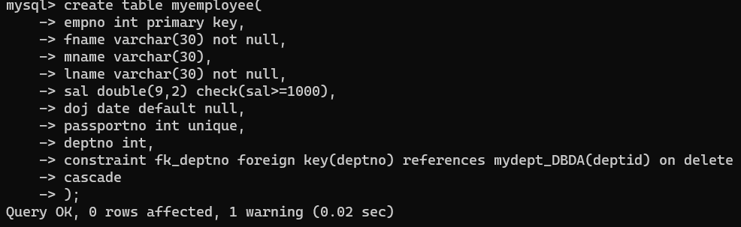

**32. Create following tables Student, Course**

**Student (sid,sname) ---------------- sid ---primary key Course(cid,cname)-------------- cid ---primary key**

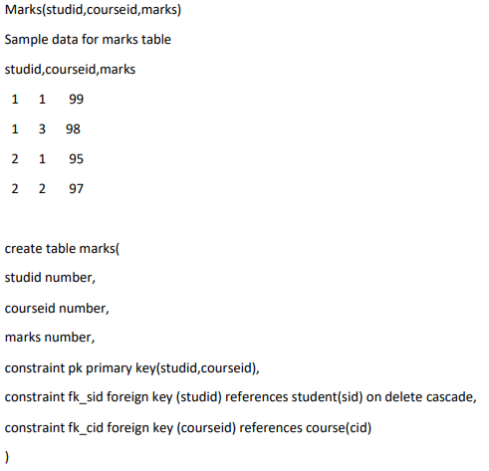

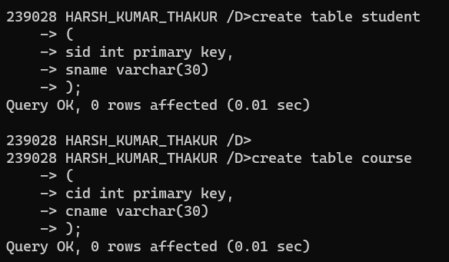

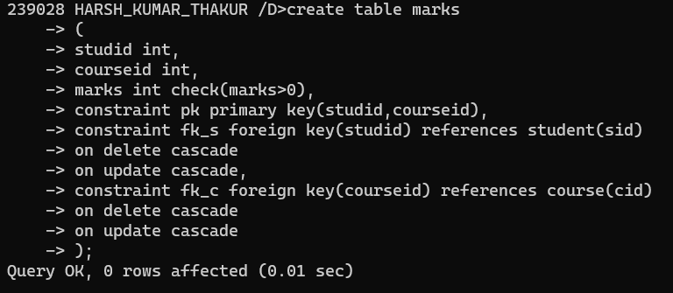

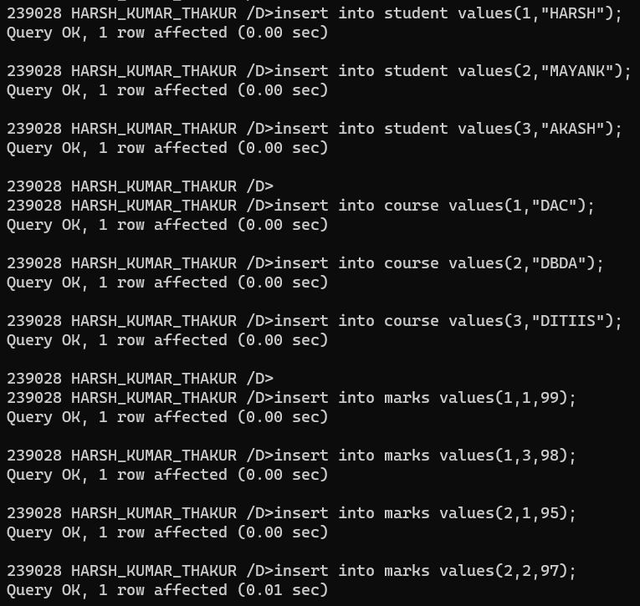

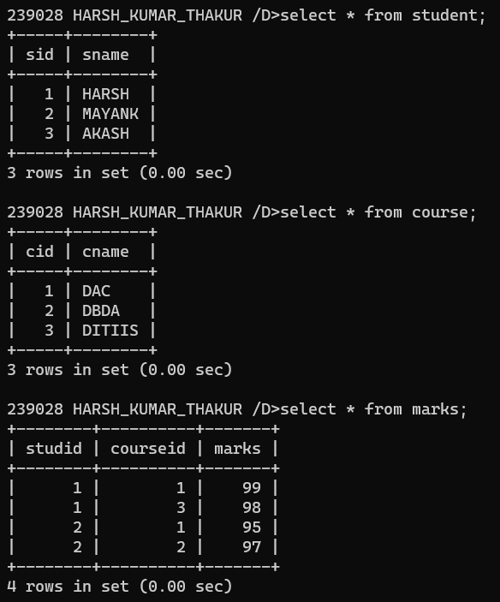

**34. Solve following using alter table add primary key constraint on emp,dept,salgrade emp ----→ empno dept---→ deptno salgrade---→ grade add foreign key constarint in emp deptno --->> dept(deptno) add new column in emp table netsal with constraint default 1000**

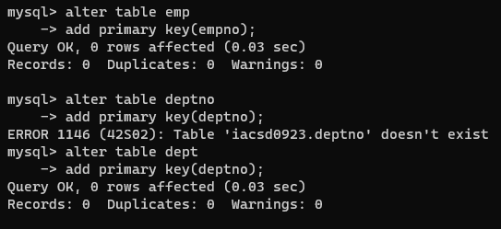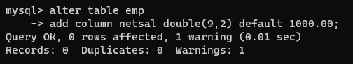

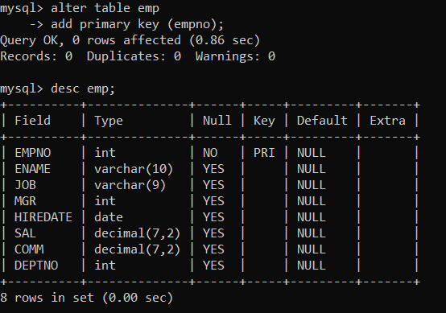

**35. Update employee sal ---- increase sal of each employee by 15 % sal +comm, change the job to manager and mgr to 7777 for all employees in deptno 10.**

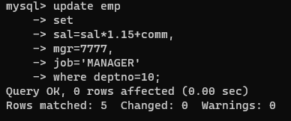

**36. change job of smith to senior clerk**



**37. increase salary of all employees by 15% if they are earning some commission**

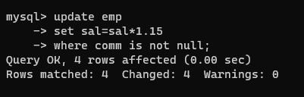

**38. list all employees with sal>smith's sal**

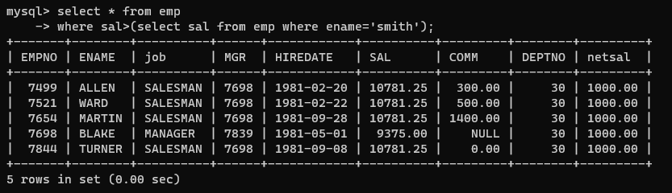

**39. list all employees who are working in smith's department**

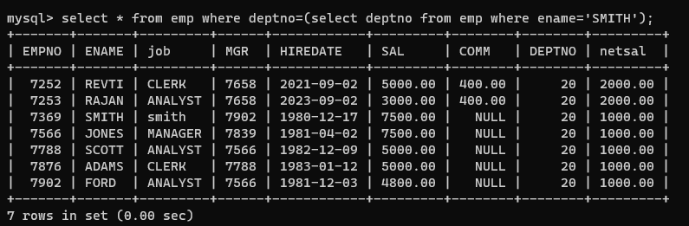

**40. list all employees with sal < rajan's sal and salary > revati's sal**

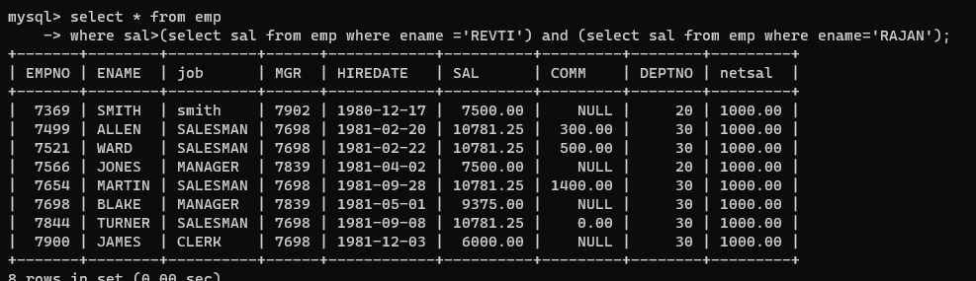

**41. delete all employees working in alan's department**

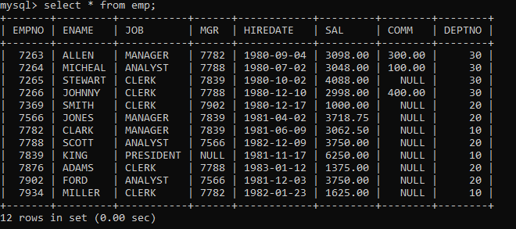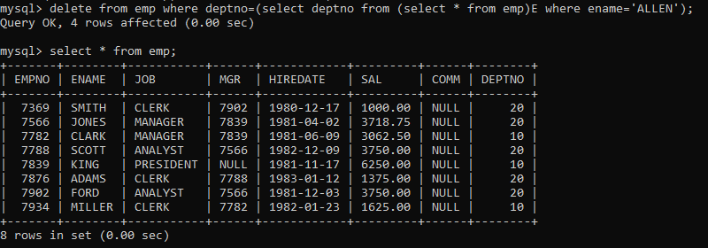

**42. change salary of Alan to the salary of Miller.**

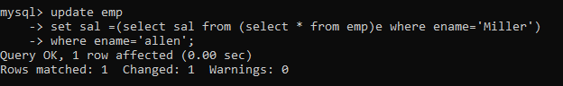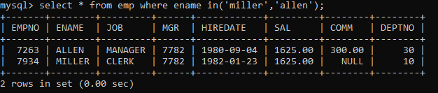

**43. change salary of all emplees who working in Wall's department to the salary of Miller.**

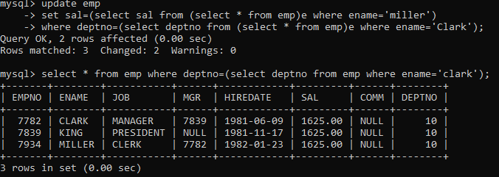

**44. list all employees with salary > either Smith's salary or alan's sal**

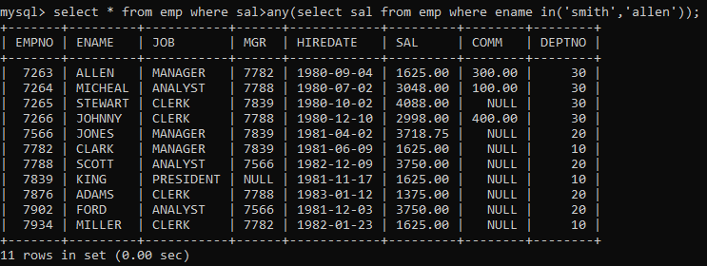

**45. list all employees who earn more than average sal of dept 10**

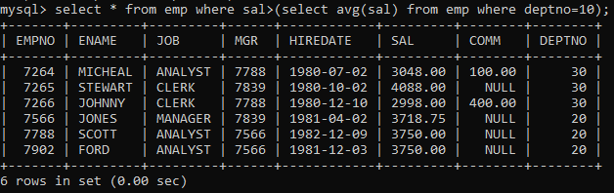

**46. list all employees who earn more than average sal of Alan's department**

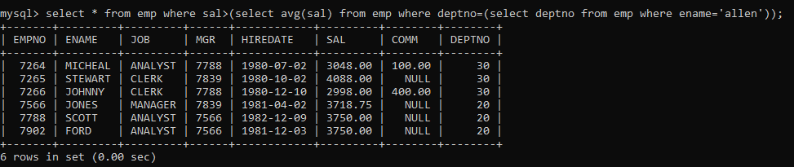

**47. list all employees who are working in purchase department**



**48. list all employees who earn more than average salary of their own department**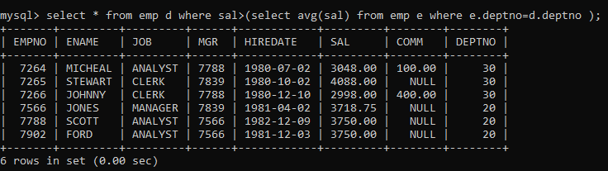

**49. list all employees who earn sal < than their managers salary**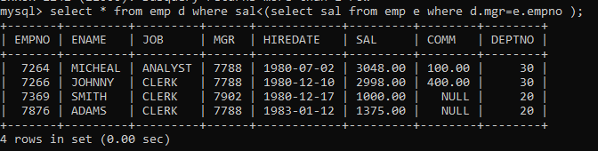

**50. list all employees who are earning more than average salary of their job**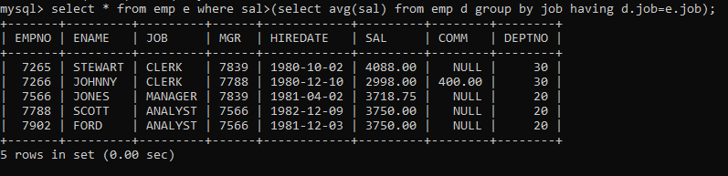

**51. display employee name and department**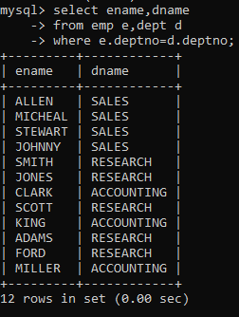

**52. display empno,name,department name and grade (use emp,dept and salgrade table)** 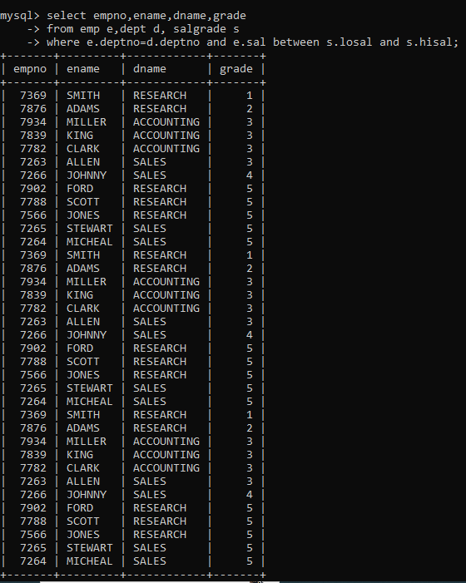

**53. list all employees number,name, mgrno and manager name**

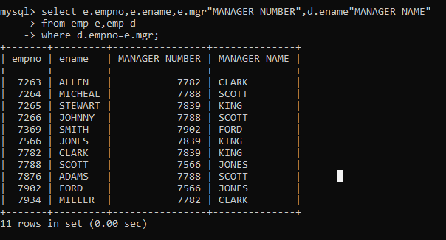

**54. create following tables and solve following questions(primary keys are marked in yellow)**

**foreign keys are marked in green**

**product(pid,pname,price,qty,cid,sid)**

**salesman (sid,sname,address)**

**category(cid,cnam, descritpion)**

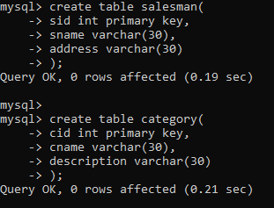

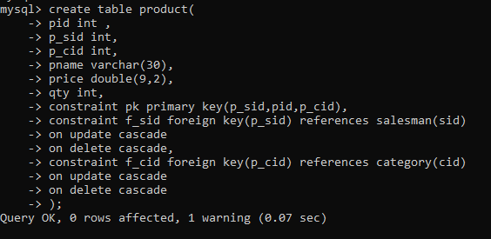

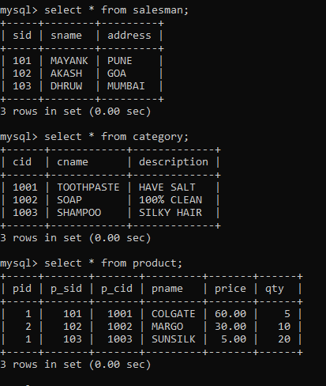

**54.1. list all product name,their category name and name of a person, who sold that product**

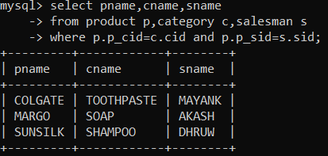

**54.2. list all product name and salesman name for all salesman who stays in pune**

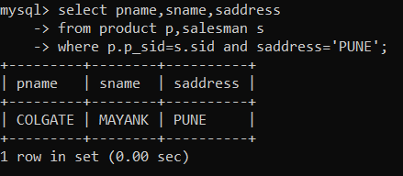

**54.3. list all product name and category name**

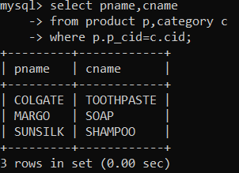

**55. create following tables and solve following questions(primary keys are marked in yellow)**

**foreign keys are marked in green**

**faculty(fid,fname,sp.skill1,sp.skill2)**

**courses(cid,cname,rid,fid)**

**room(roomid,rname,rloc)**

**faculty**

**fid fname spskill1 spskill2**

**10 kjzhcjhz a b**

**11 sdd x z**

**12 lksjk a x**

**13 ksdjlkj a b**

**courses**

**cid cname rid fid**

**121 DBDA 100 10**

**131 DAC 101**

**141 DTISS**

**151 DIOT 105 12**

**Room**

**roomid rname rloc**

**100 jasmin 1st floor**

**101 Rose 2nd floor**

**105 Lotus 1st floor**

**103 Mogra 1st floor**

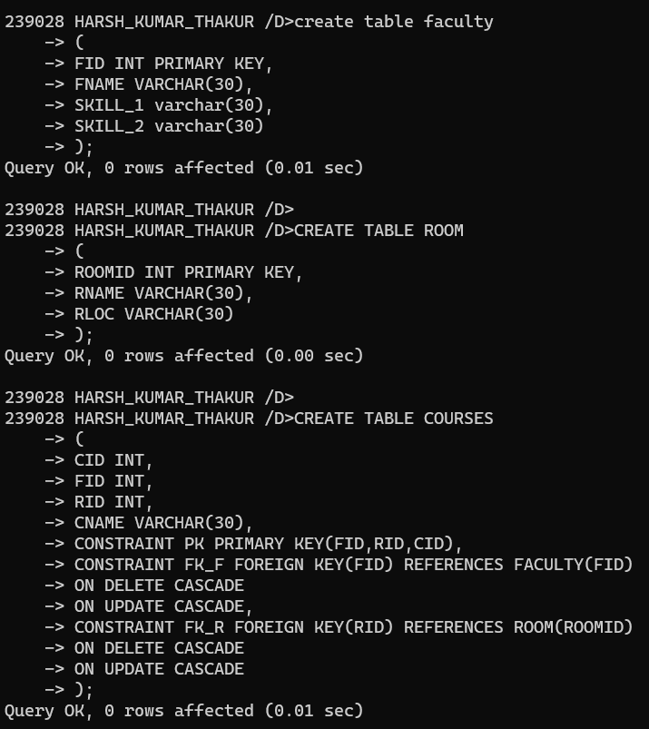

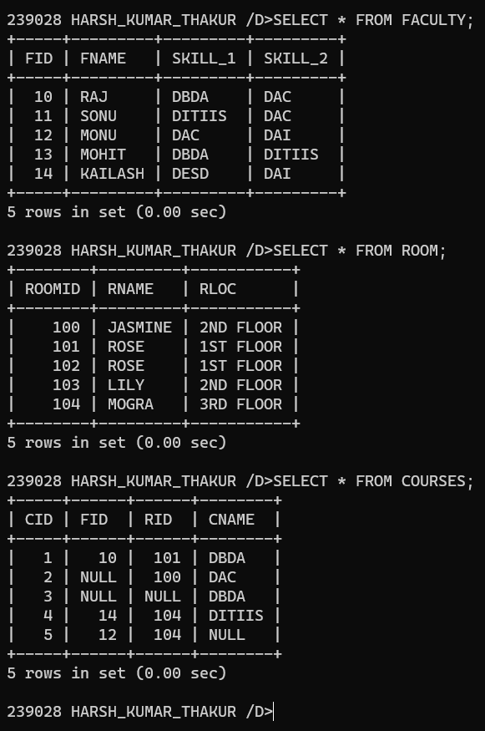

**1. list all courses for which no room is assigned and all rooms for which are available**

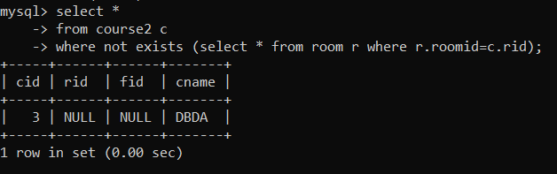

**2. list all faculties who are not allocated to any course and rooms which are not allocated to any course**

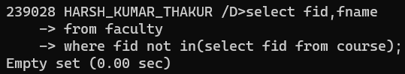

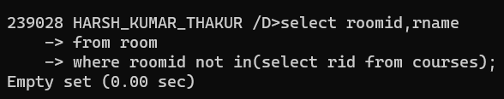

**6. display time table --- it should contain course details , faculty and room details**

